Proposal for Autonomous Vision-Aided Vehicle (AVV)

Mohammad Ali Sharifi

Yousaf Nazari

Contents

1 Abstract 2

2 Introduction 3

3 Description of the Project 3

4 Considered Solutions 3

5 Our Proposed Solution 4

6 About the Team 4

6.1 Mohammad Ali Sharifi 4

6.2 Yousaf Nazari 4

7 Supplies, Equipment and Budget 5

7.1 Equipment Costs 5

7.2 Materials Costs 5

8 Appendix A 6

8.1 Timeframe and Schedule (Gantt Chart) 6

Table of Figures

Figure 1 – Prototype of chassis design for the AVV 2

Figure 2 – Gantt chart detailing timeframe and scheduling for project deadlines and deliverables 6

Table of Tables

Table 1 – Table of equipment and costs 5

Table 2 – Table of materials and costs 5

# Abstract

The Autonomous Vision-aided Vehicle (AVV) was proposed by Optimistic Inc. to help with search and rescue missions. Optimistic Inc. wanted to create the AVV to go into hazardous sites (most likely where a natural disaster has taken place) to track and find injured people. We, Yousaf Nazari and Mohammad Ali Sharifi, have proposed a concept and prototype for an AVV that will meet the requirements for the AVV that Optimistic Inc. has asked for. We have made some changes to the proposed concept that Optimistic Inc. put forward but we have described why these changes were necessary and why our solutions work just as well, if not better. Both of us have an extensive background in mechatronic systems and we are both more than qualified to deliver a product that will satisfy the needs of Optimistic Inc. Our solution also comes with a budget that is reasonable and we have detailed how the money will be spent. We have also scheduled our time and made deadlines for specific dates and deliverables.

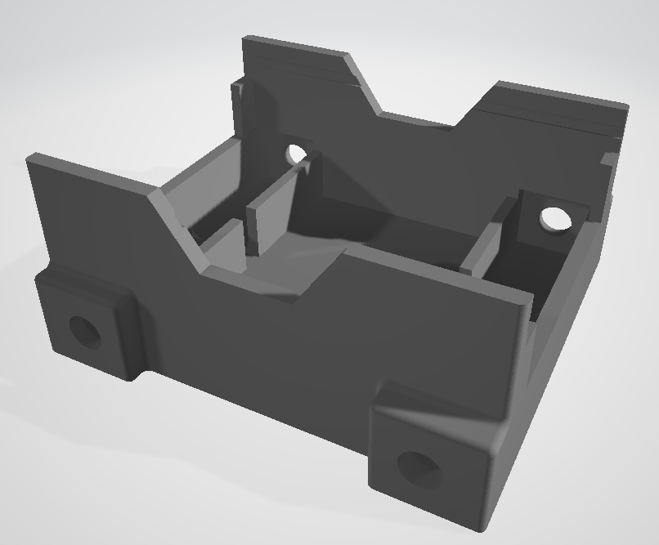

Figure 1 – Prototype of chassis design for the AVV

# Introduction

The AVV can be used to reduce the risk of human exposure to hazardous situations while at the same time helping to save lives of people who have been trapped or harmed by a natural disaster. The AVV is prototype which can be adapted to many situations in the future. For example, it can be used to move heavy obstacles in order to get to trapped individuals or it may be used to transport injured people who are unable to move to nearby rescue sites.

The AVV will be designed and operated by two of our staff members. After the design is completed and built a training session will follow and documentation on how to use the AVV and specifications for the AVV will be provided. Safety procedures and maintenance will also be included in these documents. On-call support will also be provided during use of the AVV robot.

A part of the documentation that will be delivered upon completion of this project will be this proposal which outlines the description of the project, introduction to team members of this project, approach and solutions to the problems, estimated budget for supplies and equipment and a timeframe for the completion of the project.

# Description of the Project

After a natural disaster, rescuers must enter dangerous situations to help people who have been harmed. In this way they are risking their own lives. There is a need for a semi-intelligent robot that can take away this risk by finding its way to a target position and back to safety.

The AVV is a four-wheel autonomous robot that can communicate wirelessly to obtain the target dynamics (colour, shape, size) through a user interface like a computer and uses a vision system to track its target. The AVV will have a semi-circular “shovel” design at the front of the vehicle to move obstacles out of its way and a foldable cart at the back of the vehicle to transport potentially injured people.

The components of the AVV will include:

* vision system to track its target
* small single-board computer to run vision system program
* ultrasonic sensors to detect obstacles in its path and avoid them
* foldable cart for transportation
* semi-circular “shovel” to move obstacles out of its way
* DC motors and driver modules
* battery.

# Considered Solutions

Several solutions were considered when designing the AVV. The first was a line following robot that would have infrared sensors to detect a line and follow it to its target. However, this is unrealistic in the environment that we are planning for the AVV since lines will not be present in areas where a natural disaster has occurred.

A second solution was a pick and place system where the robot has some sort of mechanism that goes to a target and picks up the target and places the target in a safer area. However, this is also unrealistic because of the uncertainty in the target size, weight, shape and other aspects.

# Our Proposed Solution

Our solution has a real-time vision system to track its target instead of following a line. The AVV will use the vision system to find a target based on its colour, shape and size. Once the AVV has found its target it will track the target and move to it. Along its path the AVV will recognize obstacles and avoid these obstacles using ultrasonic sensors. The AVV will do two things based on the shape and colour of the target. If the target is spherical the AVV will roll the sphere to a specified location (HOME) using its “shovel”. If the target is a cube the AVV will turn its cart to the target and the target will be loaded onto the cart and the AVV will then move to HOME.

To do the above tasks AVV will utilize the following systems:

* Real-time vision processing
  + Camera module
  + Small single-board CPU
* Navigation system
  + Ultrasonic sensors to avoid obstacles and to measure the distance from a target
* Motion control system
  + Motor driver module (H-bridge amplifier)
  + Microcontroller to produce pulse width modulation (PWM) signals (speed control)
* Power supply
  + Battery module
  + Voltage regulation

# About the Team

The following section describes our team and competencies.

## Mohammad Ali Sharifi

With a passion for electronics, programming and automation in general, Mohammad Ali joined BCIT mechatronics and Robotics program on 2017 and ever since he has been exposed to various automation and control system related topics in lectures and hands on experience in extensive BCIT lab sessions.

Mohammad Ali has assembled and modified 3D printers as hobby, which improved his trouble shooting and problem solving skills.

## Yousaf Nazari

Yousaf Nazari has previous three years of previous schooling in a Bachelor of Science program from Mount Royal University. He also has experience in working with large engineering projects from working in a Stucco company which handled large projects like mansions, houses and sheds. He also has an interest in working with his hands and tools which he developed from working with his father on minor projects around his house like backyard decks, fencing and various other projects. He also has an aptitude and great interest for programming and working with heavy equipment such as the ones that can be found in the machine shop at BCIT.

# Supplies, Equipment and Budget

The following section lists our equipment and materials and approximately how much they will cost

## Equipment Costs

|  |  |  |
| --- | --- | --- |
| Item | Option | Cost |
| Digital Multimeter | BCIT Labs | $100/term |
| Oscilloscope | BCIT Labs | $150/term |
| Hand tools | BCIT Labs | $50/term |
| 3D printing | BCIT Labs | $100/item |
| Milling | BCIT Labs | $100/part |
| Computers | BCIT/personal | $200/term |
| Casting | BCIT Labs | $100/term |
| Total |  | $800 |

Table 1 – Table of equipment and costs

## Materials Costs

|  |  |  |
| --- | --- | --- |
| Item | Option | Cost |
| Motors | 12V motors | $100 |
| Battery | 9V battery pack | $35.00 |
| Camera | Smraza HD camera | $35.00 |
| Single-board computer | Raspberry Pi 3 Model B+ | $47.95 |
| Sensors | Ultrasonic | $15.00 |
| Microcontroller | Arduino | $12.99 |
| H-bridge amplifier | L298 Dual H-bridge DC Motor Controller | $10.50 |
| PCB |  | $100 |
| Linear belt |  | $50 |
| Total |  | $406.44 |

Table 2 – Table of materials and costs

# Appendix A

## Timeframe and Schedule (Gantt Chart)



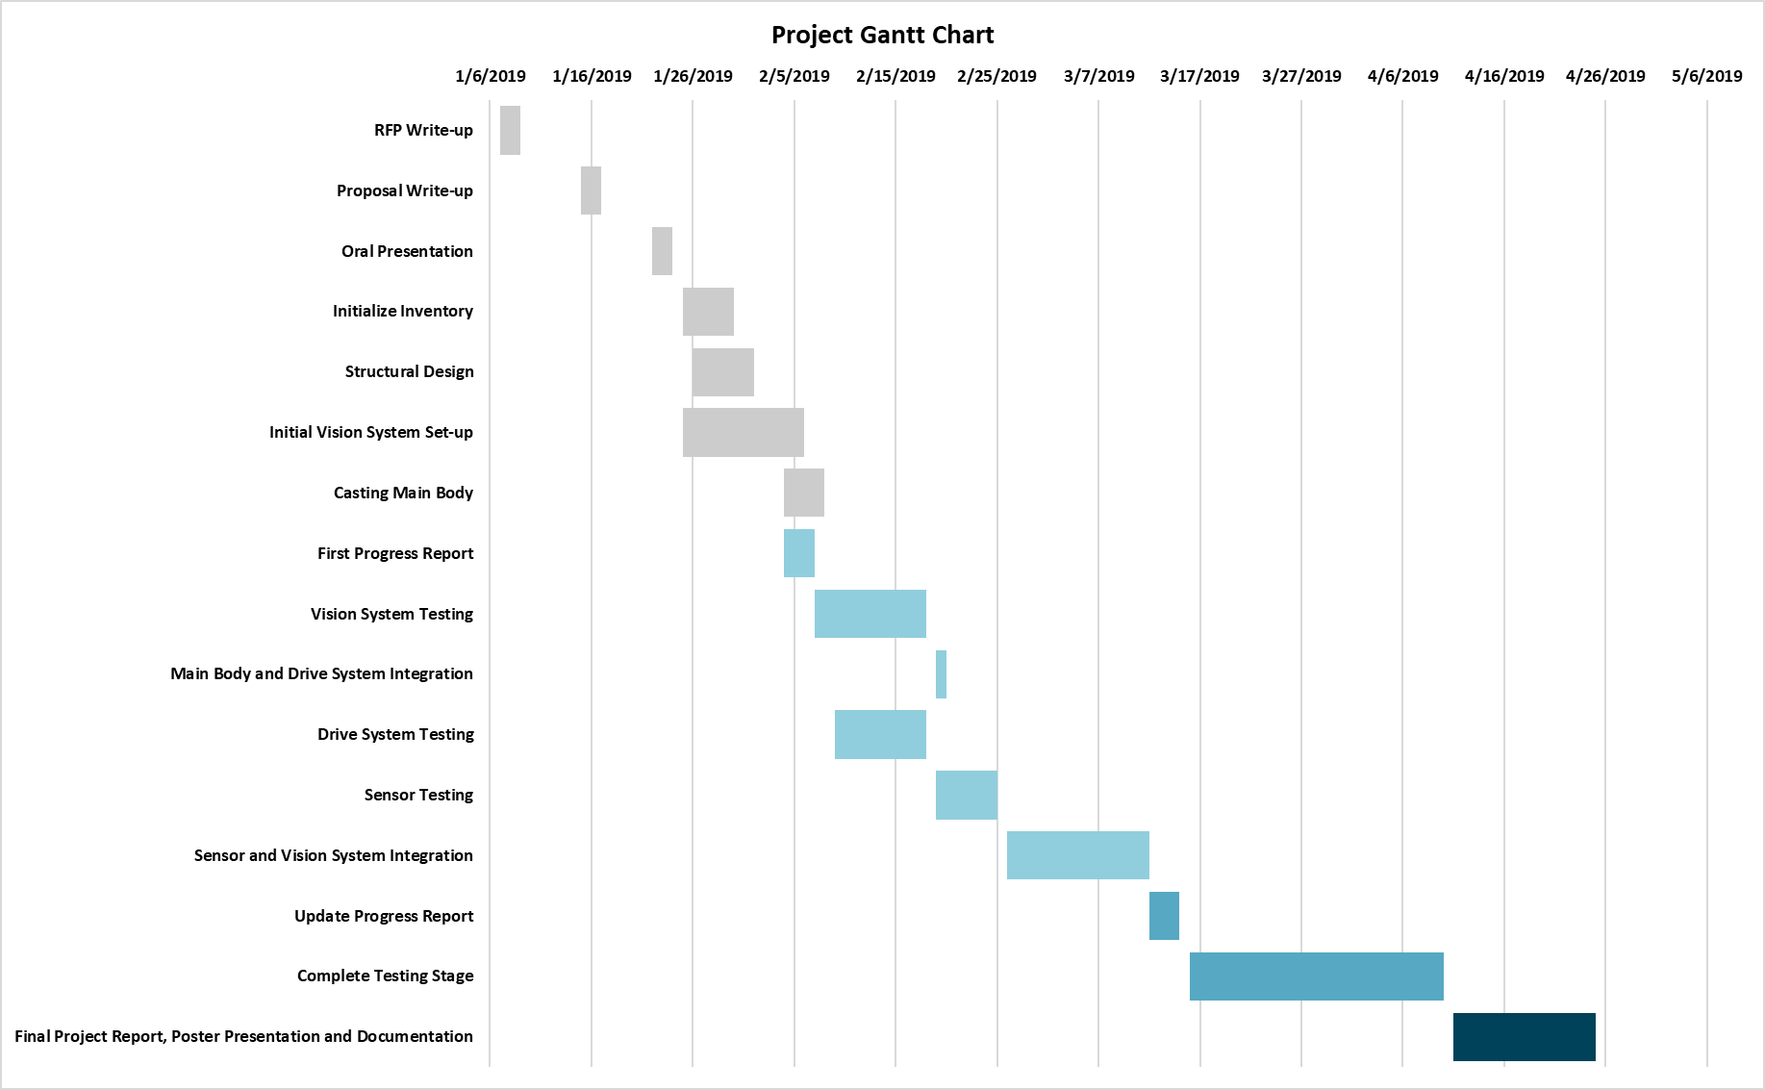

Figure 2 – Gantt chart detailing timeframe and scheduling for project deadlines and deliverables